**ADVANCE EXCEL ASSIGNMENT 11**

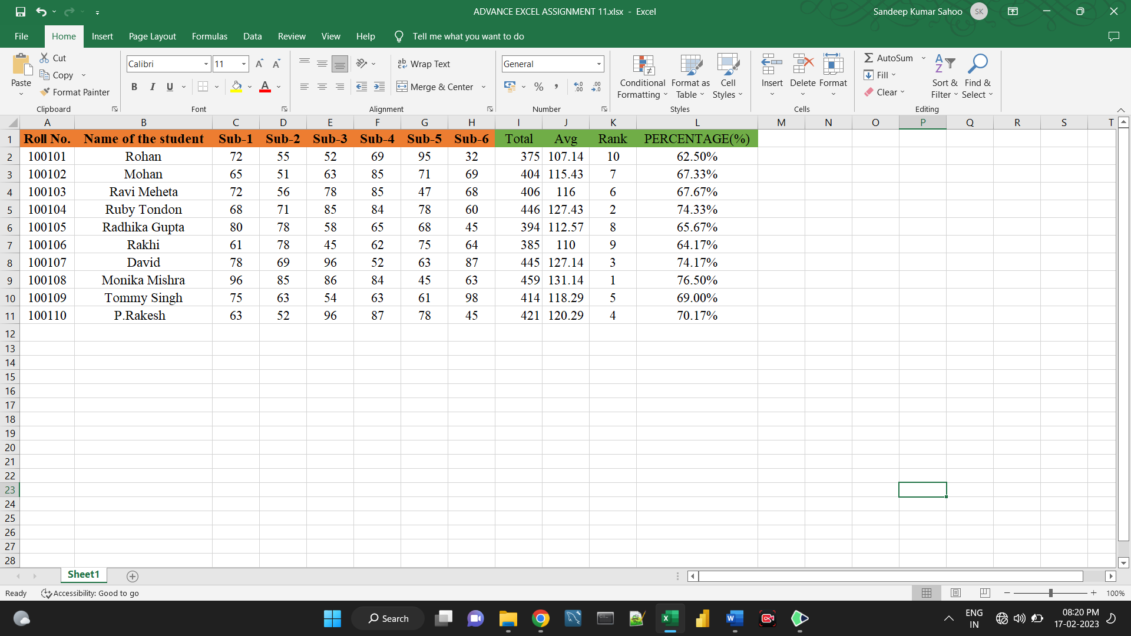

**1. Find the Minimum Marks and Maximum marks scored by each student.**

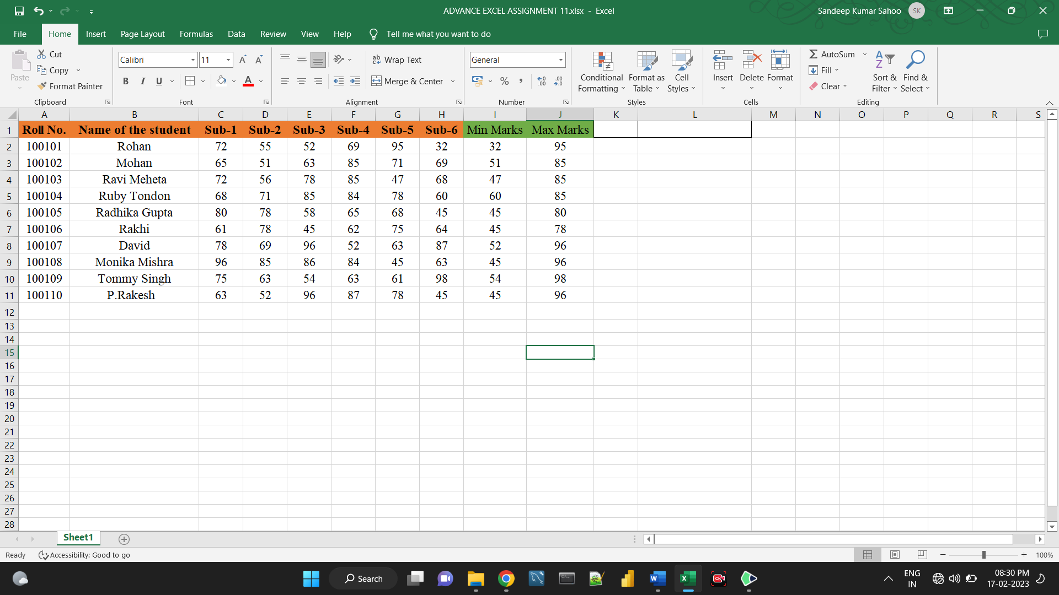

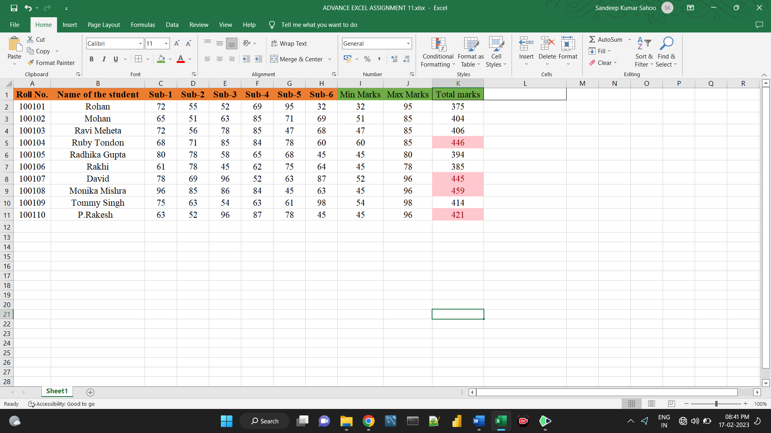**2. Calculate the totals for each student, use conditional formatting to highlight the top students who have scored more than 420.**

**3. Calculate the length of the names of each student.**

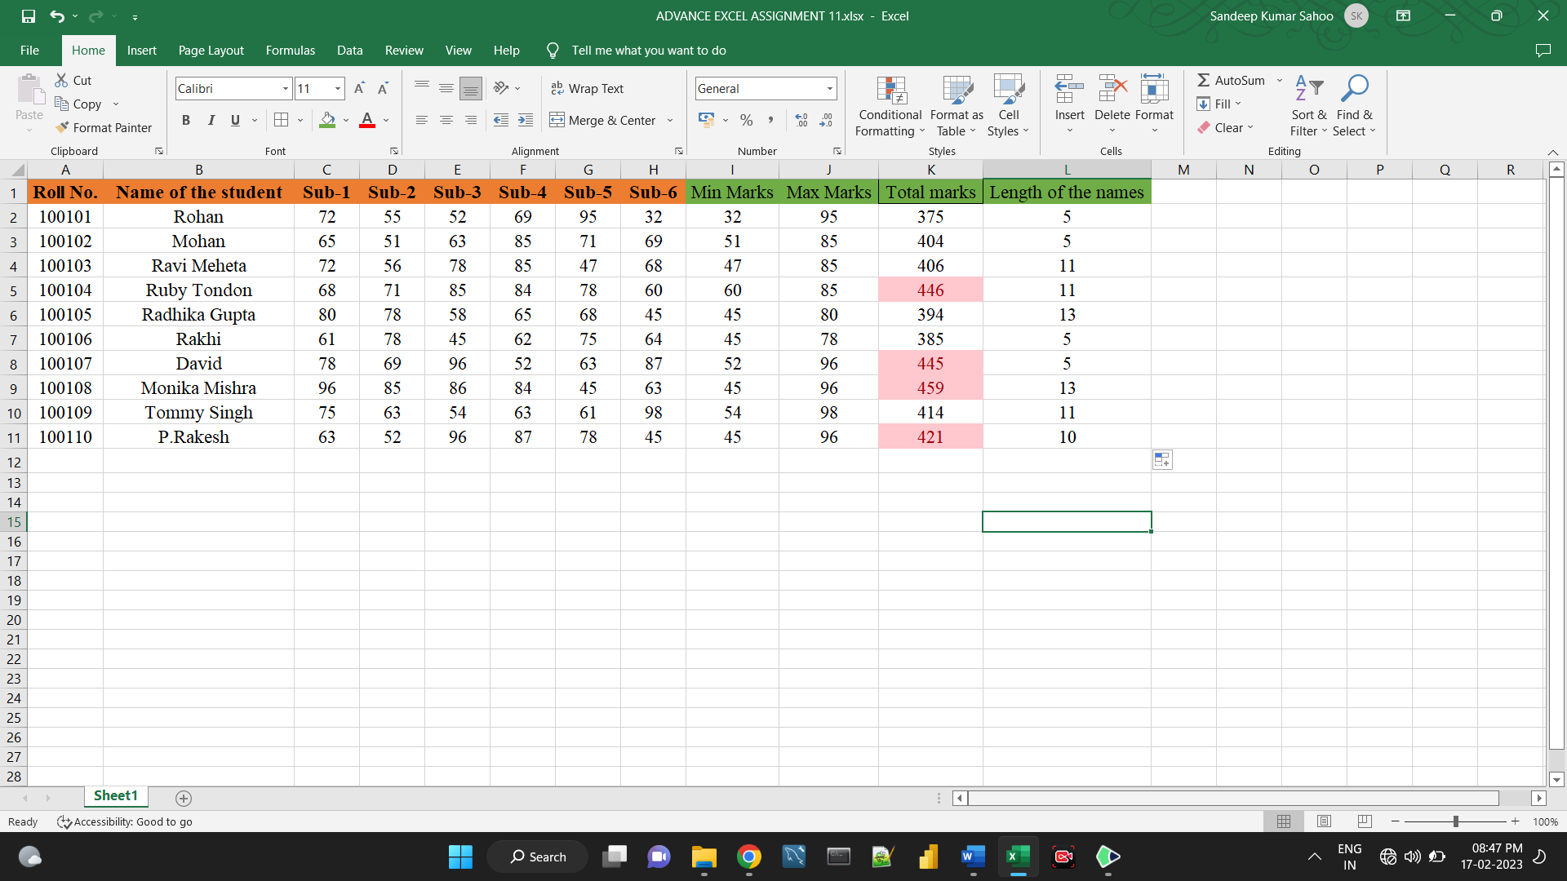

**4. Replace the Name Rakhi with Rocky. Use Formulas**

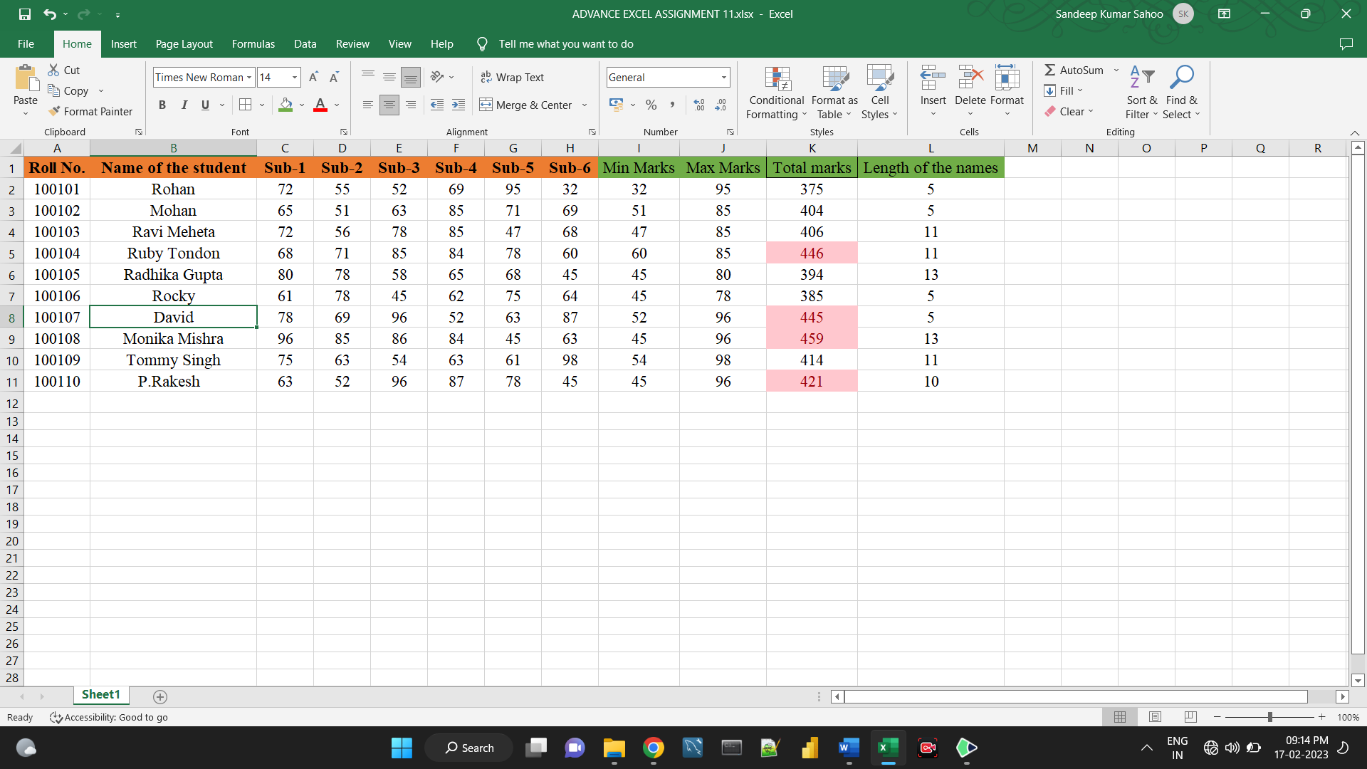

**5. Combine the Roll Numbers and Names. Use formulas. The end result should look like below.**

**100101Rohan**

